AIM: To learn:

* + to display an image on screen using GUITexture

**Preparation**

* Create a new, empty Unity project
* Create folder “Scenes”, to store your scenes
  + Save into this folder the current (empty) scene as “scene1”
* Create folder “Images”

**Notes**

* GUI is an acronym for Graphical User Interface
  + GUIs are the parts of computer applications and programming languages for displaying static and interactive visual objects to the user, such as:
    - Buttons
    - Images
    - Menus
    - Etc.
* In computer games and 2D/3D graphics systems, a bitmapped image is often called a “texture”
  + That’s why the Game Object to display an image file is called GUI Texture
* To save the current Scene
  + Select Menu
    - File ⏐Save Scene
  + Use keyboard shortcut
    - command/CTRL-S
    - i.e.
      * (Mac) command-S
      * (Windows) CTRL-S

# Import an image into your “images” folder

Do the following:

* Select the images folder in the Project panel
* Choose menu:
  + Assets ⏐ Import New Asset…

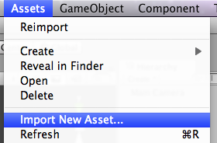

* Locate the file to be imported (in this case the image file “hello_world.png”)

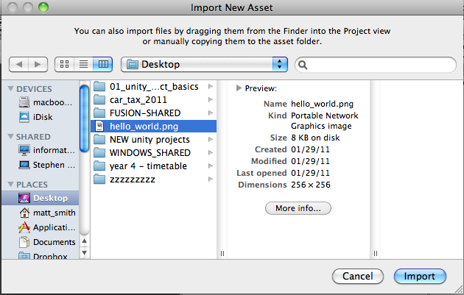

The imported image should now appear in your images folder in the Project panel:

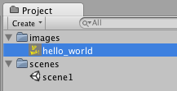

***FAQ: My image isn’t in my images folder?***

***Just drag it over the images folder to move it there …***

# Create a new GUITexture based on the selected image

Do the following:

* Ensure the hello_world image is selected in the Project panel
  + (if no image is selected, then a Unity logo will be the basis for your GUITexture…)
* Choose menu:
  + Game Object ⏐Create Other ⏐ GUI Texture

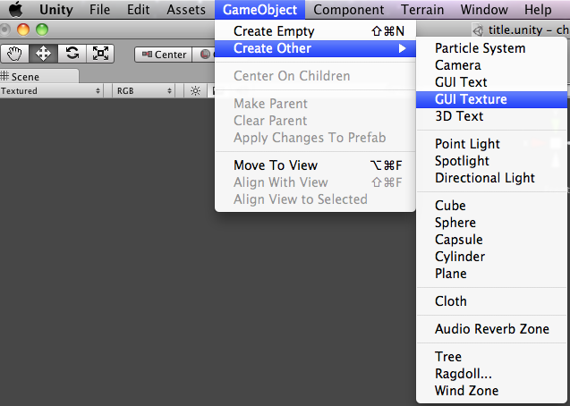

You should now see the image displayed in the Scene panel:

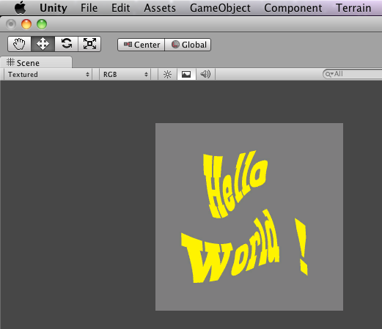

# Save and run your program

Do the following:

* Save your work (i.e. the scene)
  + Command / CNTL-S
* Change back to the Unity application, and click the run button
  + This is the standard triangle pointing to the right “playhead” controller to run/play something (the one on the LEFT of the group of 3 buttons!)
  + In this case, it runs your application from the beginning

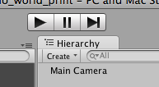

* you should now see the image running in the Game panel

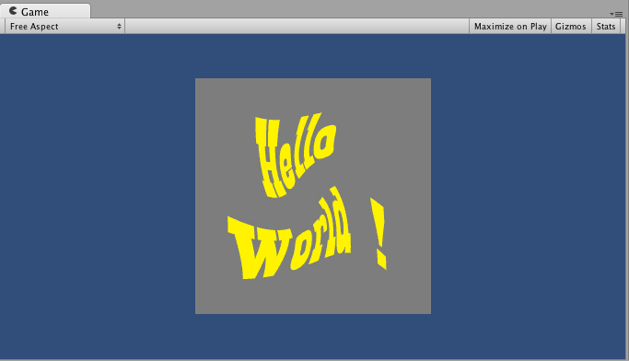

**Congratulations!**

**Your first Unity game !**